Experiment No.2
Aim:
To design an Entity Relationship (ER) diagram for the Company database and convert it into relational tables.

Description:
The system includes entities such as Employee, Department, Project,and Location. Employees work in departments, departments control projects, and employees may work on multiple projects. Departments can also be located in different locations. The ER diagram helps in organizing company data, reducing redundancy, and ensuring data integrity.
Entities and Attributes
EMPLOYEE
Represents an employee working in the organization. Attributes:

- SSN (Primary Key)
- Name
- Address
- Salary
- Sex
- SuperSSN
- DNo

DEPARTMENT
Represents adepartment in the organization.
Attributes:
- DNo (Primary Key)
- DName
- MgrSSN
- MgrStartDate

PROJECT
Represents aproject handled by the department.
A ttri butes:
- PNo (Primary Key)
- PName • PLocation
- DNo

DLOCATION
Represents the location of a department. Attributes:

- DLoc
- DNo
Relationships:

- EMPLOYEE – DEPARTMENT
Relationship: Worked
An employee works in one department, and a department can have many employees.
- DEPARTMENT – PROJECT
Relationship: Works On
A department controls many projects, and each project is associated with one department.
- EMPLOYEE – PROJECT
Relationship: Works On
An employee can work on multiple projects, and a project can have multiple employees. The relationship stores the attribute Hours.
- DEPARTMENT – LOCATION
Relationship: Located In
A department can be located in multiple locations.

ER diagram:
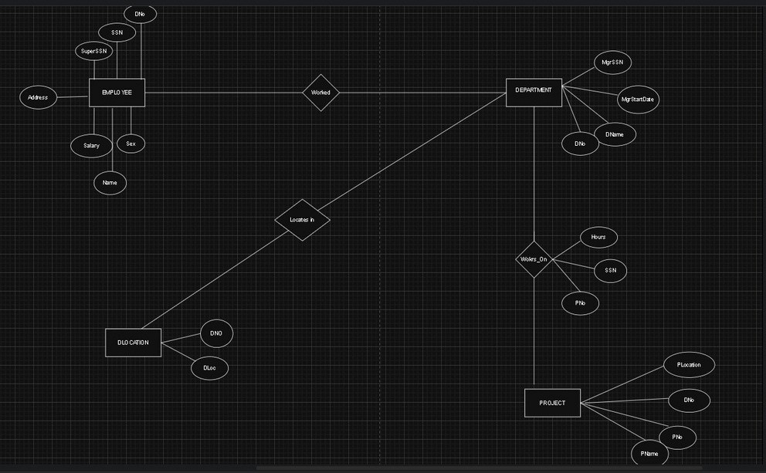
Conclusion:
This ER diagram clearly illustrates the relationships between employees, departments, projects, and locations in a company. It serves as a strong foundation for designing a well-structured and efficient company database system.

